Understanding the Manufacturer’s Focus
by
IDIS 444-502, Group 7
Tyler Abney
Christopher Chow
Yuxiao Song
Ricardo Zaragoza

Submitted to the Department of Engineering Technology & Industrial Distribution
Texas A&M University
in partial fulfillment of the requirements for the degree of
BACHELOR OF SCIENCE IN INDUSTRIAL DISTRIBUTION

December 2021

Executive Summary
The North American Association of Utilities Distributors (NAAUD) has expressed a desire to understand manufacturer focus. In meetings with NAAUD, it has been noted that the problems stem from end user actions. To best serve NAAUD's objectives, the project was refocused to end users in these categories:
- Customer Perspective of Market
- Customer Operations
- Customer Projects
To that end, two recommendations have been developed based on the categories above:
- Adjust timelines with customers to reflect increased lead time.
  - Increasing project timelines to reflect changes in supply chain.
  - Survey has shown end users assume historical lead time based on pre-Covid experience.
- Customers to exchange more detailed information with suppliers is advised.
  - Provide more information to help prepare plans and orders earlier.
Implementation of these recommendations will serve to mitigate the changes in lead time and limit impacts of projects being ordered inside lead time. This allows more time for lead time and strengthen forecasting and planning.

Table of Contents
Executive Summary 2
Chapter I: Introduction 4
Chapter II: Problem Statement 5
Chapter III: Literature Review 7
Chapter IV: Methodology 10
Chapter V: Data Analysis 12
Chapter VI: Conclusions and Recommendations 14

Chapter I
Introduction
NAAUD (North American Association of Utility Distributors) is a group of member distributors that provide products and services to electric utilities in Canada and the United States. Associate members of this association include leading manufacturers of products used by electric utilities. Customers of these distributors and manufacturers are electrical utilities that own and operate the critical infrastructure that makes up the US electric grid. A great deal of regulation and oversight is placed on the industry as a whole which has presented issues due to the unusually long lead times being experienced due to supply chain impacts caused by the Covid-19 pandemic.
Currently, the market for the electric utility industry is under notable duress from longer lead times and usage of emergency orders. Raising costs for materials, supply chain constraints, need for grid optimization, asset replacement, and many other factors has caused increases in challenges for the electric utilities industry. These instances all occurring at the same time has caused dramatic increases in lead time across all members of the industry. Supply uncertainty and increased demand occurring in conjunction has then further intensified increases in lead time across the industry. Mitigation of the on-going effects and action to prevent further impact is a primary objective for NAAUD and associated members.

Chapter II

Problem Statement
From the meetings with NAAUD members and associates, several problems have been identified. Due to the global supply chain crisis and material shortages, electrical manufacturers usually don’t have sufficient contingency plans or alternate suppliers in place for such extreme circumstances. Electrical industry manufacturers have traditionally relied on just-in-time supply from stockpiles in their supply chain to support their response. While this approach with customers and distributors has served the industry well, it can also lead to the need for heavier inventory and other inefficiencies for the distributor. Additionally, many customers incorrectly estimate how many products they need to fulfill projects. This leads to unexpected and extraordinary orders that send ripples up the supply chain all the way to the manufacturer's supply chain. With inaccurate forecasts and today's volatile supply chain, manufacturers are experiencing major issues in production scheduling and deliveries. Furthermore, the sudden increase in order volume has noticed significant increases in lead time.
Now with the increase in issues needing attention, manufacturers and distributors are having issues communicating effectively and quickly enough to prevent gaps in supply from delaying work. Two way communication from manufacturer to distributor and distributor to customer needs to be much more effective for quality of the services to improve.
This project aims to determine how distributors can help optimize production plans, inventory positions, and identify how external factors may impact supply. This project will provide guidance and recommendations to the members of NAAUD, its associates, and customers to address these deficiencies. Ideally, these recommendations will provide distributors the ability to improve their service and maintain profitability. Recommendations will focus on NAAUD members in particular.

Chapter III

Literature Review
To better organize the project, the team organized research into three main topics; external factors, customer operations, and customer projects. The team has done individual research as well as conducted meetings with NAAUD members and associates to better understand the challenges that they are facing.
External Factors
The impact from recent external factors on manufacturers has been documented extensively for the electrical utility industry. Of note, reporting agencies like the US Census Bureau have reported increases as high as 18% for metrics such as unfulfilled orders from 2020 to 2021 (US Census, 2021). However, the interpretation of the causes of these results is with contention. For example, some companies report only minimal disruptions from COVID stating operations have adapted to the situation (Santos, 2021). While others state the problem is from supply chain disruptions caused by COVID (Bowman, 2021). This disagreement on the causes of the supply chain disruptions is significant as it represents that the industry has not adopted a response to the changes themselves. This lack of response translates to the industry being slow to respond as a whole, which is seen by the Texas response to their recent cold snap. During that cold snap, the power generation companies were unable to uphold their contract's terms and were fined approximately $750,000 (Schwartz et al., 2021). This has resulted in the Federal Energy Regulation Commission (FERC) now stepping in to reexamine industry standards (O'Driscoll & Mielcarek, 2021). These recent actions allow us to see how the industry acts to change as a whole and the extent regulatory powers influence the industry.
Customer Operations
Due to meetings with the NAAUD members and associates, the project was reexamined and shifted from manufacturer production and inventory to customer operating procedures and project management. With this, the research confirms unusually high increases in lead time across most product categories (Gutierrez). Further research into these increased lead times shows a multitude of factors with the most prevalent factor being material shortages for manufacturers (Hoffer, 2021). Copper, for example, recently hit a ten year high, and is only expected to rise in the coming years, given that its demand is being driven by the eco-friendly energy solutions (Schneider Electric). This increase in demand has left suppliers shorthanded and often out of stock. The situation has been further exacerbated by power generation company forecasts not reflecting the industry as a whole due to the transition to remote work prompted by COVID-19 (NAAUD, 2020).
Additionally, an interview conducted with Brett Turner, who is the operation manager of Brownstown Electric Supply, mentioned that the electric industry in the Midwest states has not been affected by COVID-19 negatively, but instead accelerated the growth speed of the industry. However, supply has not been able to keep up with demand and distributors cannot accurately forecast the future demand of the next month or a quarter based on historical data. With the reports reviewed above, it has been confirmed that lead time is related to the supply shock and increasing demand caused by COVID.
Customer Projects
The final aspect of the topics that have been identified is utility projects. Historically, NAAUD's utility customers have sent only necessary information to other suppliers (NAAUD, 2020). With historical data no longer being accurate, demand increasing, and supply chains being strained, it has become necessary to reevaluate how customers perform projects.
In an interview conducted with Ricardo Zargoza, CEO of Hyper Gas, Mr. Zaragoza provided helpful insight to the problems in communication about projects between customers and distributors. Mr. Zaragoza stated that the lack of communication and increased lead times have led to trouble for both the customer and distributor. Mr. Zaragoza further explains that with increased communication between both parties instead of using forecasts based on historical data both parties are more satisfied and efficient due to a decrease in lead time changes and gaps in supply. These interviews have allowed insight on how customers and distributors exchange information and the current state of operations for both parties.

Chapter IV

Methodology
In the development of this project, it was conceived at the beginning of how the project would naturally flow as well as the primary objectives. The project was split into two major categories referred to as Primary and Secondary. This split was done to prepare the data in an easy to follow way and to understand the progression as the project went on.
Secondary
The Secondary portion of the project was done first and focused on research as a foundation for the project. Data collection utilized business articles, federal publications, and scholarly articles. Main focus for data collection was primarily from publicly traded companies and from power generation companies. The data collected from these sources was focused on understanding the industry condition and on-going trends. Criteria for selection as a secondary source required that information to be from a company in the electrical utilities industry, not be older than six years, and be based on US standards.
Primary
The Primary portion of the project utilized additional research and was used to build credibility of the project. Data collection for this portion consisted of a survey to electrical utilities along with interviews during the first phase of the project. Interviews were designed to help understand NAAUD members and associates perspective of industry conditions and issues being faced by manufacturers. Sample size for interviews was ten members from NAAUD distributors and manufacturers. The interviews were unstructured using a guide found in Appendix A to ensure interviews stayed on-topic and relevant. The survey included 32 people from the utilities, ranging from managers to directors with 17 successful online survey responses. People to survey were chosen based on references and contacts given by NAAUD members. As for the survey's design, the questions were split into three categories: how lead time impacts utility decisions, ways NAAUD members and associates can influence utility planning, and utility perspective on the market. These categories contain a total of 14 multiple choice questions. A full depiction of the survey's questions can be found in Appendix B.

Chapter V

Data Analysis
Data analysis of the project was conducted using two methods, content analysis and grounded theory analysis. Content analysis covers the secondary data. Grounded theory will cover the primary data. Further elaboration can be found in their respective sections.
Content Analysis
Content analysis, which is the method of examining arranged data and noting patterns and trends that emerge from the data, was used on the data from the secondary phase of the project. Data was categorized into three sections: supply-chain trends, lead time concerns, and regulatory forces. Specific articles were scrutinized for trustworthiness based on how well they addressed the aforementioned categories. Those considered accurate enough were then scanned for patterns and trends and cross-referenced with NAAUD members and associates during monthly meetings to confirm relevance.
Grounded Theory
Grounded theory was used to analyze the data from the primary phase of the project. This process consists of developing theories and ideas during the process of collecting and analyzing data. To this end, notes taken during the interviews were reviewed and marked for key phrases as more interviews were conducted. For example, interviews discussed issues of unfulfilled orders and material shortages which concluded that they faced increased freight issues and shipping concerns. This then fed into the next interview which focused on issues of freight and shipping concerns.
The primary phase of the project transitioned into the survey with NAAUD utility customers. The survey was facilitated using Qualtrics which was used to filter out unusable data (incomplete surveys and empty responses) which was then exported to Excel for data analysis. Analysis of data consisted of isolating question data and seeing the percentage of responses for each question. Impressions and ideas created during this process are recorded on each questions' respective summary and adjusted as more survey responses are submitted. An example of a question's summary can be seen below and in Appendix C.
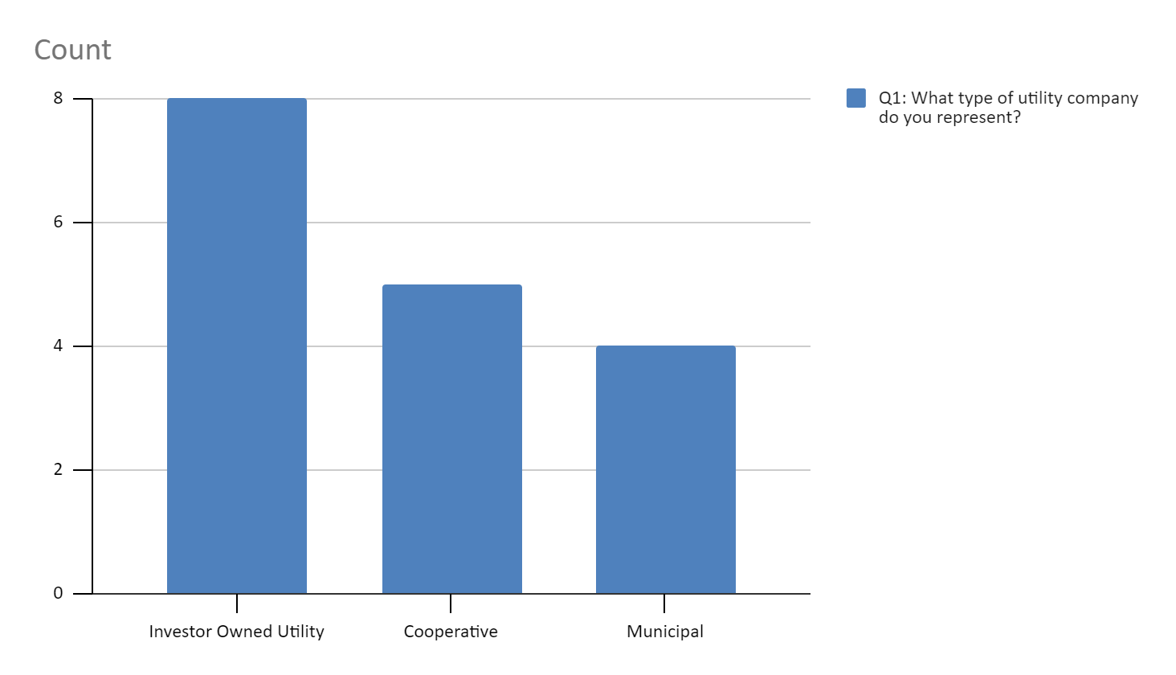*Type of utility company represented by representative

Chapter VI

Conclusions and Recommendations
Based on data collected, conclusions show signs that utility customers are operating on previous historical data when planning projects and relatively few utilities offer the choice of additional future projections for distributors. Using historical data rather than forward looking information results in not allowing enough flexibility in project planning to account for supply chain issues.
Emphasize with Utilities the Need to Extend Project Timelines
Information assembled from both the secondary and primary phases of the project confirm that utility customers, NAAUD distributors, and manufacturers believe existing supply chain issues will not improve in the near term. However, utility projects are based on historical data that does not reflect the increase in lead time. With increased demand, NAAUD distributors and manufacturers have issues supplying materials on-time. Additionally, manufacturers cannot increase production as their lines are full and the material shortages resulting from the supply chain issues. Therefore, it is recommended that utilities and distributors collaborate closely on project schedules to minimize project disruptions and reduce the need for emergency orders, which are increasingly difficult to perform in the current environment.
This recommendation is based on the idea of using the NAAUD distributor relationships with their utility customers. Pushback is possible due to short-term costs on the utilities from increasing timeframes. Reduction of project disruptions and lower cost due to less emergency orders needed is assumed to be able to mitigate short-term costs. Support from existing relationships with customers may be necessary to help support the proposal.
Emphasize With Utilities the Need to Increase Information on Projects
Project information from end users may also be a constraining factor with current supply chain issues. Because of this, it is recommended to emphasize that the utilities release more project information to help plan demand and supply requirements. It was noted during the interviews that order volumes have increased dramatically with little forewarning. The result is added risk to operations as it increases likelihood of gaps in supply. Having utilities provide more project information such as schedules or forewarning of upcoming projects will allow increased accuracy for planning inventory and forecasting demand.
This recommendation is based on the idea of increasing the ability to foresee the needs for projects. Survey responses from utility personnel indicate they do believe that additional information will be beneficial for distributors. However, utility personnel believe there is unneeded risk in releasing additional information. Proper implementation of this recommendation will require assurance to utility personnel that releasing additional information is worth the risk. To that end, it is advised to offer incentives such as discounting, mutual information exchange, or higher prioritization in cooperation. With mutual exchange, it is believed that this recommendation will see much higher success and ensure both parties benefit.

Appendix A
Good morning, My name is Christopher Chow, I am a student at Texas A&M University conducting research for NAAUD.

We are conducting research for your perspective of the industry and we would like to collect your response for understanding the current market. We plan to use this information as the foundation for our project.

I was wondering if I could take 30 minutes of your time to discuss a few questions regarding your operations.

If you do not know the answer to the question, please try and answer to the best of your ability.
(Keep the purpose of the project in mind)

Questions:

- Have lead times for orders had a noticeable change?

- Have order sizes increased compared to past years?

- If yes, which of these contributed to the order size increase?

- When drafting projects, data usually is taken from how long ago?

- At what stage of a project are distributors involved?

- What kind of project information is given to distributors?

- Would giving more project data help reduce order lead time?

- When placing orders, how are they generally placed?

- Generally what kind of lead time is expected from orders?

Appendix B
Q1. What type of utility company do you represent?
- Investor Owned Utility
- Cooperative
- Municipal
Q2. Has significant change in lead times affected projects/workplans?
No Effect | Little Effect | Noticeable Effect | Significant Effect
Q3. Has your volume of projects/workplans changed compared to past years?
Significant Decrease | Noticeable Decrease | Slight Decrease | No Change | Slight Increase | Noticeable Increase | Significant Increase
Q4. If yes, which of these are present issues in projects/workplans? (Select all that apply)
- Increasing prices
- Supply shortages
- More projects
- Lead time
- Freight issues
- Other
Q5. How far in advance is data gathered when planning projects/workplans?
- 3 months
- 6 months
- 9 months
- 1 year
- 1+ years
Q6. Typically, at what stage of a project/workplan are suppliers contacted?
- Initial project concept
- Budget approval
- Bill of material planning
- Bidding
Q7. What kind of project information is given to suppliers? (Select all that apply)
- Additional timelines / Optional timelines
- Design specs
- Bill of materials
- RFQ (Request For Quote) package
Q8. Please rate the following on a scale of Very Unbeneficial to Very Beneficial

Do you think it would be beneficial to give more information to the supplier?
Very Unbeneficial | Likely Unbeneficial | Unsure | Likely Beneficial | Very Beneficial
Q9. When placing orders, how are they generally placed?
- Distributor website
- Automated order
- Manual purchase order
- Other
Q10. What is a reasonable lead time for wire & cable?
- 4 - 8 weeks
- 9 - 14 weeks
- 15 - 20 weeks
- 20+ weeks
Q11. What is a reasonable lead time for single phase transformers?
- 14 - 20 weeks
- 21 - 30 weeks
- 31 - 40 weeks
- 40+ weeks
Q12. What is a reasonable lead time for pole line hardware and connectors?
- 2 - 4 weeks
- 5 - 8 weeks
- 9 - 12 weeks
- 12+ weeks
Q13. What material do you see current lead times impacting project on-time completion? (Select all that apply)
- Wire & Cable
- Tranformers
- Hardware and connectors
- Pads / Pedestals / Cabinets
Q14. What is your outlook on supply chain issues (pricing and availability) over the next 6 months?

Appendix C
Based on the data collected, our current results from survey are as follows:
- Distribution of respondents
  - 7 responders are from Investor Owned Utility companies
  - 5 responders are from Cooperative utility companies
  - 4 responders are from Municipal utility companies.
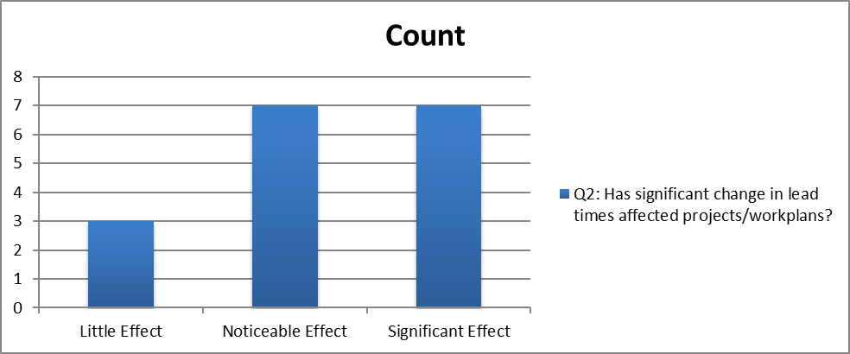
- Impact of lead time on projects/work plans
  - 0 responders have experienced no significant changes
  - 3 reported little effect
  - 7 reported noticeable effect
  - 6 reported significant effects in lead times affected projects/work plans.
  - Most of the respondents have noticed effects in lead times affecting projects and work plans.
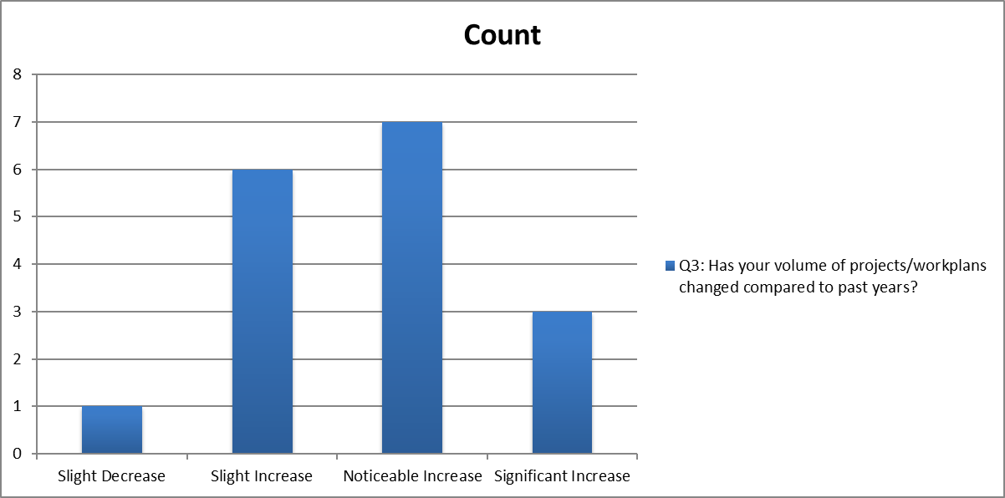
- Changes in project count
  - 0 responders reported that there was a significant decrease in volume of projects/ work plans compared to past years
  - 0 reported noticeable decrease
  - 1 reported slight decrease
  - 0 reported no change
  - 6 reported slight increase
  - 6 reported noticeable increase
  - 3 reported a significant increase in volume of projects or work plans.
  - Most of the respondents reported that they have been experiencing increased projects compared to the past years.
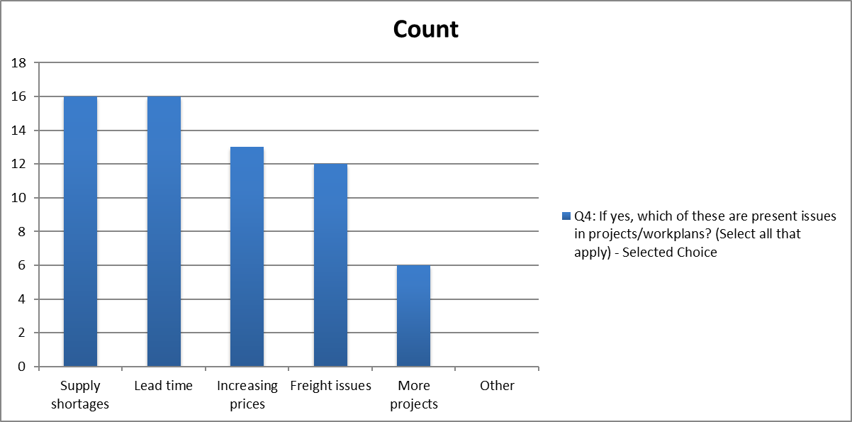
- Issues faced in current projects/work plans
  - 12 responders reported increasing prices
  - 15 reported supply shortages
  - 5 reported more projects
  - 15 reported lead time issues
  - 11 reported freight issues
  - 1 reported other issues.
  - Transport and material issues are the most commonly reported issues.

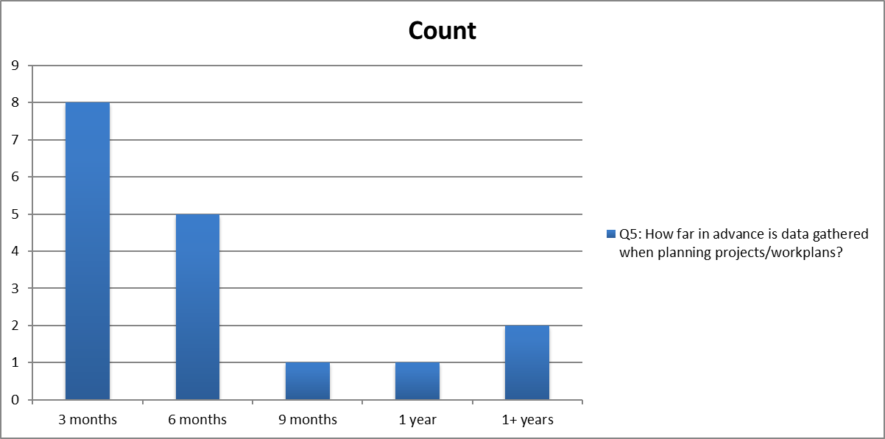
- Gathering data in advance when planning projects
  - 7 reported 3 months ahead
  - 5 reported 6 months ahead
  - 1 reported 9 months ahead
  - 1 reported 1 year ahead
  - 1 reported 1+ years ahead
  - Data is generally gathered within 3-6 months ahead of time
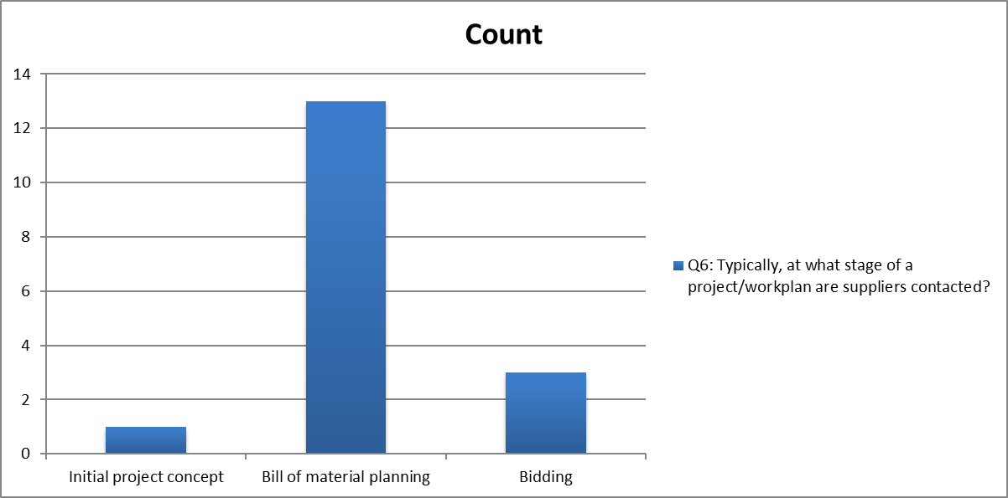

- When distributors are involved in projects
  - 1 responder reported that they contact the suppliers at initial project concept
  - 0 reported at budget approval stage
  - 12 reported at bill of material planning stage
  - 3 reported at bidding stage.
  - Most of the purchasing agents would contact the supplier at the billing of material planning stage.
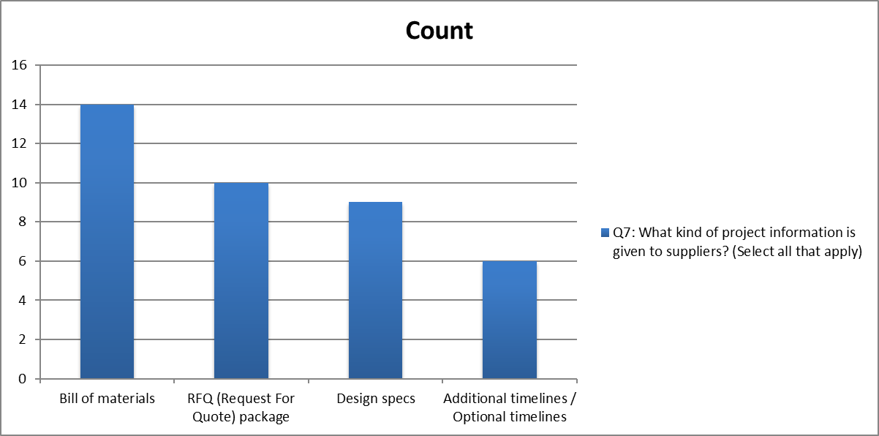
- Information given to distributors when involved
  - 5 responders reported that they provide additional timelines or optional timelines to suppliers
  - 8 responders provide design specs to suppliers
  - 13 provide bill of materials
  - 9 provide request for quote packages to suppliers.
  - Less end users would provide the timelines for the project to the suppliers
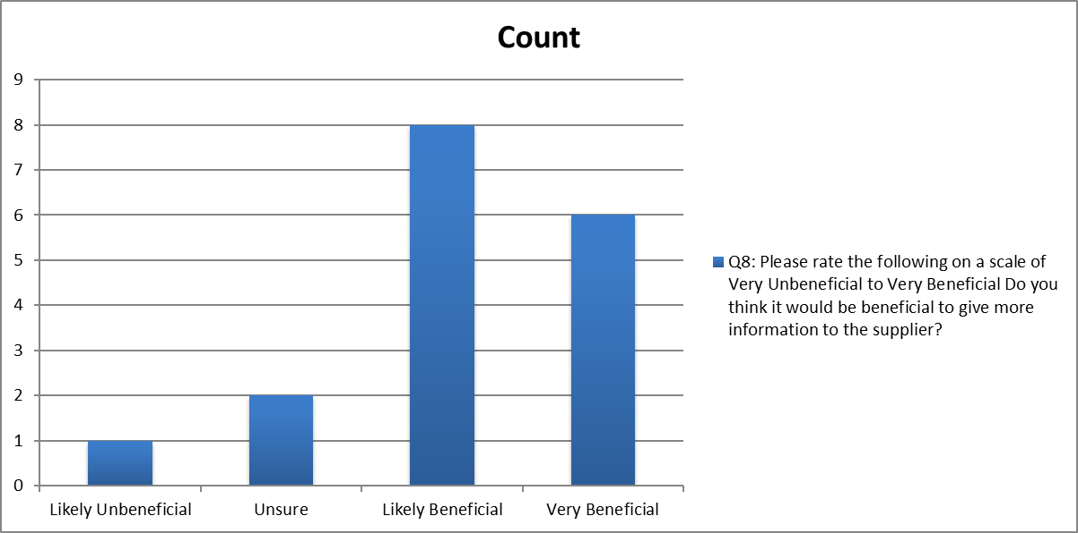
- End user perspective of information value
  - 0 responders think it would be very unbeneficial to give more information to the suppliers
  - 1 reported likely unbeneficial
  - 2 reported unsure
  - 7 reported likely beneficial
  - 6 reported very beneficial to provide more information to the suppliers.
  - Most of the end users agree that providing more information to the suppliers would be beneficial to the suppliers.
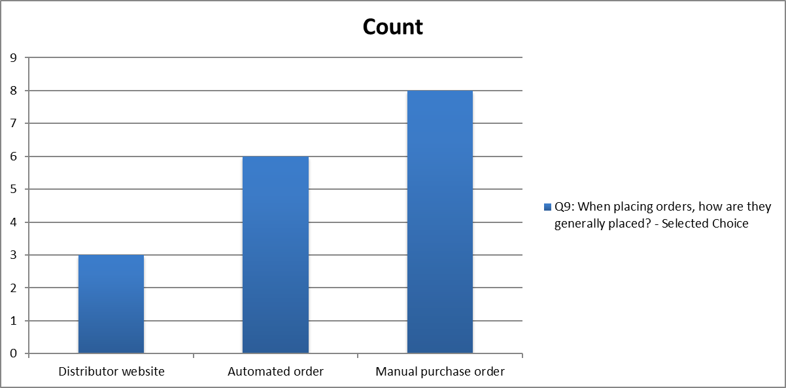

- How orders are placed
  - 3 reported using Distributor websites
  - 6 reported using Automated order
  - 7 reported using Manual purchase order
  - 0 reported using Other methods.
  - Most orders are split between manual and online order methods
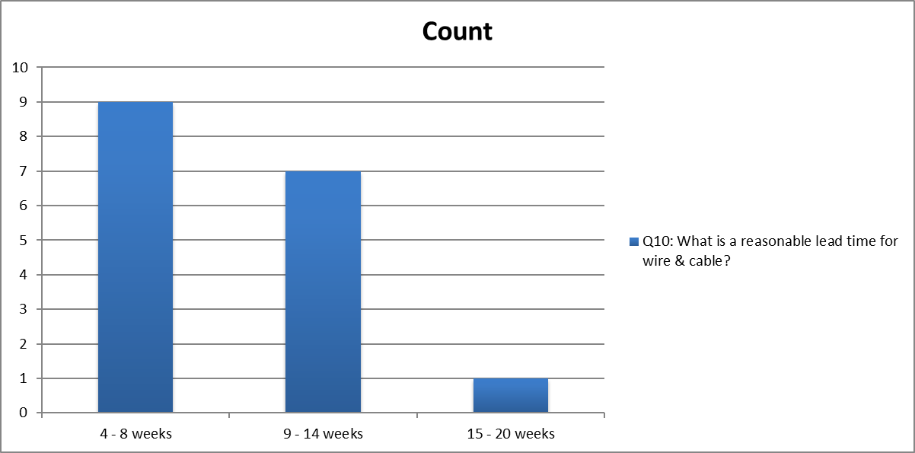
- Reasonable lead time for wire & cable
  - 9 responders reported that 4-8 weeks is a reasonable lead time for wire & cable
  - 6 reported 9-14 weeks
  - 1 reported 15-20 weeks
  - 0 reported 20+ weeks
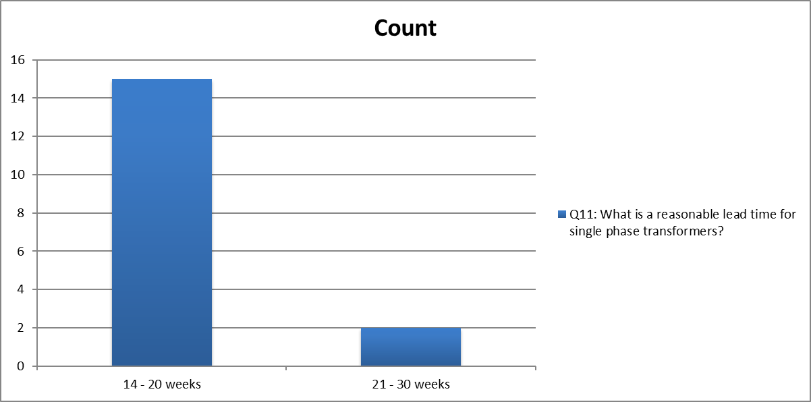
- Reasonable lead time for single-phase transformers
  - 14 reported 14-20 weeks
  - 2 reported 21-30 weeks
  - 0 reported 31-40 weeks
  - 0 reported 40+ weeks.
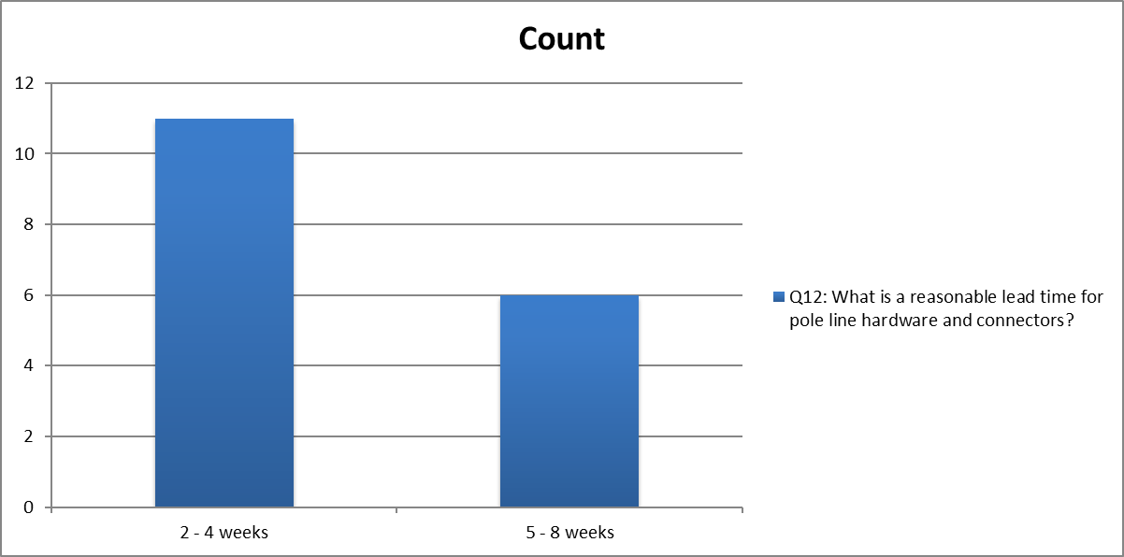
- Reasonable lead time for pole line hardware and connectors
  - 11 responders reported 2-4 weeks
  - 5 reported 5-8 weeks
  - 0 reported 9-12 weeks
  - 0 reported 12+ weeks.
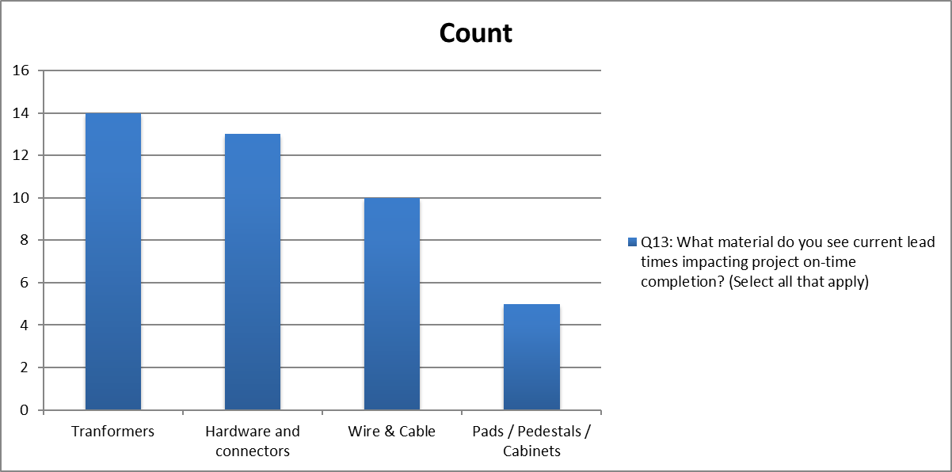
- Which product often impacts project on-time completion
  - 9 responders reported wire & cable in current lead times impacting project on-time completion
  - 13 responders reported transformers
  - 12 reported hardware and connectors
  - 5 reported pads/ pedestals/ cabinets.
  - Customers often chose the smallest lead times for products but then answered those products impact on-time completion.
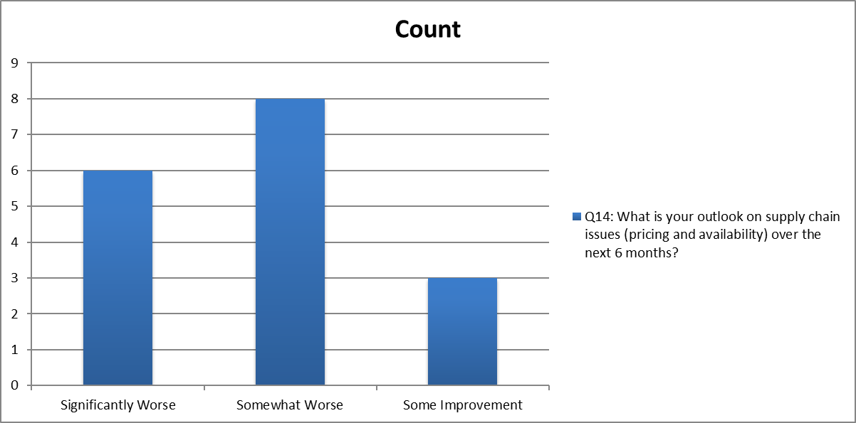
- Perspective of supply chain issues changes
  - 5 reported significantly worse
  - 8 reported somewhat worse
  - 0 reported no change
  - 3 reported some improvement
  - 0 reported significant improvement.
  - Overall negative estimations for supply chain issues by end users

Citations
allBusiness. "Shipping as a Profit Center". allBusiness, https://www.allbusiness.com/shipping-as-a-profit-center-844-1.html . Accessed 30 June 2020.
Bowman J. R. (2021, February 23). "The Near-Shoring Trend: Will China's Loss be Mexico's Gain?". Supply Chain Brain. https://www.supplychainbrain.com/blogs/1-think-tank/post/32683-the-near-shoring-trend-will-chinas-loss-be-mexicos-gain
Brett, T. (2021, February 2). Interview. (S. Yuxiao, Project Member)
Broderick, Sean. "Issues With Newest Engines Provide Early MRO-Proving Opportunities". Aviation Week Network. aviationweek.com/mro?NL=AW-05 . Accessed 3 Nov. 2020
Croft, John. "New Engines: Flurry of Activity Despite Downturn". FlightGlobal. https://www.flightglobal.com/new-engines-flurry-of-activity-despite-downturn/89341.article . Accessed 4 Nov. 2020
Hoffer, T., & Underground Services, I. . (2021, August 17). Current shortages are challenging construction & utility industries. SoftDig. Retrieved from https://www.softdig.com/blog/shortages-materials-labor/.
Kenton, Will. “How Supply Chains Work.” Investopedia,Investopedia, 16 July 2020, www.investopedia.com/terms/s/supplychain.asp.
National Transportation Safety Board. Safety Assumption Report. National Transportation Safety Board. https://www.ntsb.gov/investigations/AccidentReports/Reports/ASR1901.pdf . Accessed 6 Nov. 2020
Naaud, North American Association of Utility Distributors. NAAUD, North American Association of Utility Distributors | North American Association of Utility Distributors, The Power to Meet Demand. (2021, June 18). Retrieved October 18, 2021, from https://naaud.org/.
NAAUD (2020-2021). Team Meetings. (C. Chow, Project Lead)
O'Driscoll, M., & Mielcarek, K. (2021, September 21). "FERC, NERC Staff Review 2021 Winter Freeze, Recommend Standards Improvements". FERC. https://www.ferc.gov/news-events/news/ferc-nerc-staff-review-2021-winter-freeze-recommend-standards-improvements
Polanich, Randi. "Applied Materials Selects SAP to Enhance Business Agility". MCADCafe. https://www10.mcadcafe.com/nbc/articles/view_article.php?articleid=220145 . Accessed 10 Nov. 2020
Santos, F. (2021, February 10). Team Meeting. (C. Chow, Project Lead)
Schwartz, J., Collier, K.,& Davila, V. (2021, February 22). "Power companies get exactly what they want": How Texas repeatedly failed to protect its power grid against extreme weather. https://www.texastribune.org/2021/02/22/texas-power-grid-extreme-weather
Siemens. (2012). The Costs and Risks Associated With Improper Service and Maintenance of Electrical Systems. https://www.downloads.siemens.com/download-center/Download.aspx?pos=download&fct=getasset&id1=A6V10702452
Schneider Electric. Sustainability. (2021). Schneider Electric. Retrieved April 3, 2021, from https://www.se.com/us/en/about-us/sustainability/climate-change/
Tom, K. (2021, February 9). Team Meeting. (C. Chow, Project Lead)
US Census Bureau: Adriana Stoica (M3 Section Chief). (2009, September 28). US Census Bureau Manufacturer' shipments, inventories, and orders main page. US Census Bureau Manufacturers' Shipments, Inventories, and Orders. Retrieved February 4, 2021, from https://www.census.gov/manufacturing/m3/index.html.
Wayne, S. (2021, February 4). Interview. (T. Abney, Project Member)
Zaragoza, R. CEO, Hiper Gas (2021, March 26). [Personal interview by author]

